
MetaSecure Corp - Security Breach in the Metaverse
Case study 2

DONE BY :
Sasha Shapsough
Jana Abdullah
Sabeen Shoufieen
Jamiel Alas ad

Introduction

What is MetaSecure Corp?
MetaSecure Corp is a company that created a virtual world called MetaSphere. It’s part of the metaverse, where people use avatars to talk, play, shop, and even feel things using special devices like VR headsets and haptic gloves.

They promised that their system was super secure — they used things like blockchain, AI, and biometric logins. But… things didn’t go as planned.

Summary of the Breach
On June 15, 2025, MetaSecure Corp experienced a large-scale cyberattack on its metaverse platform, MetaSphere. The attackers compromised user accounts, transferred digital assets, manipulated identities, and extracted private data.

Attack Vectors and Security Failures

- Attack Vectors – How the Hackers Got In:

- Third-Party API Exploit
Hackers took advantage of a weakness in the identity verification system provided by a third-party API.

- Malicious Virtual Items
They hid malware inside digital items sold in the metaverse marketplace, which infected users who purchased them.

- Cross-Platform Movement
The attackers used the platform’s integration features to secretly move between different virtual spaces without being detected.

- Steganography for Data Theft
Sensitive user data was secretly encoded into avatar movements and object properties, then extracted by the hackers.

- Smart Contract Exploitation
The hackers discovered a logic flaw in the blockchain smart contracts, allowing them to bypass the verification of digital assets like MetaCoins.

- Botnet via IoT Devices
They used compromised Internet-of-Things (IoT) devices to build a hidden network (botnet) that helped them control and coordinate the attack remotely.

- Security Weaknesses – What Went Wrong

- No Risk Checks for Third-Party Tools
The company didn’t properly test or monitor the third-party tools they were using.

- No Scanning of Marketplace Items
Digital items uploaded to the metaverse marketplace weren’t scanned or isolated before being sold.

- Poor Platform Segmentation
The virtual world wasn’t divided into secure zones, so once attackers got in, they could move around freely.

- Weak Behavioral Monitoring
There were no strong systems to detect unusual user actions or avatar behavior in real-time.

- Slow Incident Response
The security team couldn’t detect or respond to the attack quickly enough.

- Unsecured Smart Contracts
The blockchain smart contracts weren’t fully tested or reviewed, which allowed the attackers to exploit them.
Comprehensive Security Architecture For A Metaverse Platform Diagram
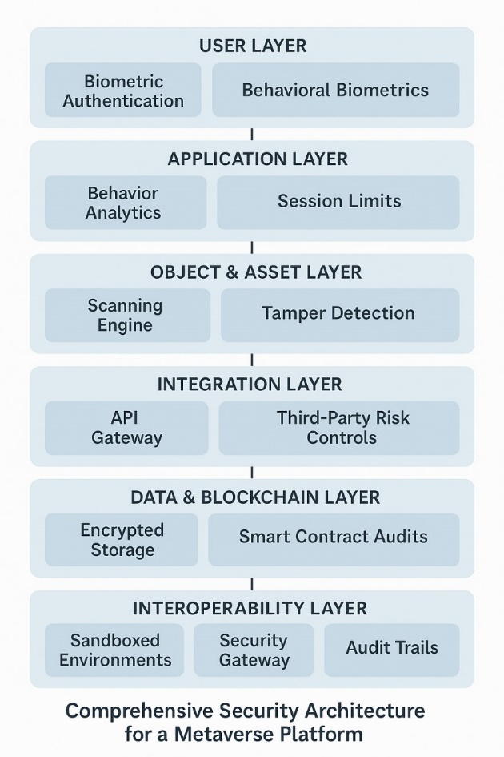

Diagram analysis

1. User Layer
What it does:
Controls how users enter the system and verifies who they are.
Key Features:
- Biometric login (face, voice, fingerprint)
- Device trust checks (ensures the user is on a secure device)
- Multi-factor authentication
Why it's important:
Prevents unauthorized users or stolen credentials from accessing the platform.

2. Application Layer
What it does:
Watches everything that happens while the user is logged in.
Key Features:
- Session monitoring for unusual behavior (e.g., logins from different countries)
- AI analytics to detect anomalies like avatar impersonation or asset misuse
- Rate limiting and timeouts
Why it's important:
Detects and stops suspicious behavior after login, before damage is done.

3. Asset Layer

What it does:
Protects all the virtual items users interact with — like avatars, land, or tools.
Key Features:
- Object scanning: to detect hidden malware in digital items
- Sandboxing: to isolate and test suspicious assets safely
Why it's important:
Prevents attackers from hiding harmful code inside things users buy or use in the metaverse.

4. Integration Layer
What it does:
Secures connections between MetaSphere and other services (like payment or ID verification tools).
Key Features:
- Zero Trust API gateway that filters all external requests
- Access control and authentication tokens
- Regular security audits for third-party services
Why it's important:
Many attacks (like in this case study) come through weak external tools. This layer blocks unsafe integrations.

5. Data & Blockchain Layer
What it does:
Protects sensitive user data and ensures secure ownership of virtual assets.
Key Features:
- Encryption of data both at rest and in transit
- Smart contract validation and auditing
- Decentralized identity management
Why it's important:
Keeps financial and personal data safe, and makes sure digital assets (like MetaCoin or land) can’t be stolen or faked.

6. Interoperability Layer
What it does:
Controls how users and data move between different metaverse platforms.
Key Features:
- Security gateways to monitor traffic between systems
- Audit logs of all cross-platform actions
- Policy-based access control
Why it's important:
Prevents attackers from hopping between platforms or using one world’s weaknesses to break into another.

Metaverse-Specific Incident Response Plan
Key Steps:
1. Detection & Alerting
- Watch for unusual haptic feedback and strange avatar behavior.
- Monitor wallet transactions for suspicious activity.
- Use AI to spot abnormal changes in the virtual world’s physics.

2. Containment

- Shut down affected areas in the metaverse.
- Freeze or suspend suspicious digital items and accounts.
- Block or isolate risky external connections.

3. Eradication

- Remove malware hidden in virtual objects.
- Fix security bugs in smart contracts and APIs.

4. Recovery

- Restore users’ digital assets from backups.
- Force users to reset passwords and verify their accounts again.

5. Post-Incident Actions

- Perform a full forensic investigation to understand what happened.
- Inform regulators and all users affected by the attack.

How is this different from traditional incident response?
Traditional incident response focuses on computer systems and networks. In the metaverse, it must also consider avatars (virtual identities) and haptic devices (physical feedback). Sometimes attacks can cause real physical discomfort to users. Plus, attacks can happen across different virtual worlds, so tracing them is more complex.

Reflection
Working on this case study made me realize how different and complex security becomes in immersive digital environments like the metaverse. Unlike traditional platforms, these spaces involve real-time interactions through avatars, VR headsets, and even haptic feedback devices. This means users don’t just share data — they live experiences, form identities, and feel emotions in these environments.
Because of this, the risks go far beyond data theft. A cyberattack can now cause emotional distress, psychological harm, and even physical discomfort, as seen when users received unauthorized haptic signals. When an avatar is impersonated or manipulated, it can feel just as violating as identity theft in the real world.
This also means that metaverse platforms carry new responsibilities. They must protect not only technical systems, but also users' digital identities, mental well-being, and physical safety. Security must include ethical AI use, transparency in behavior monitoring, and strong consent-based policies. On top of that, many of today’s laws aren’t yet designed for these immersive spaces, so companies must go beyond legal requirements and lead with accountability.
Personally, this case study shifted how I view cybersecurity. It’s no longer just about firewalls and encryption — it’s about protecting humans in digital realities. As the boundary between the digital and physical world continues to blur, we need smarter, more holistic, and more ethical security solutions.

Conclusion
The MetaSecure Corp breach highlights the evolving and deeply complex nature of cybersecurity in immersive digital environments. Unlike traditional systems, the metaverse introduces new attack surfaces — from haptic feedback and biometric data to smart contracts and behavioral tracking. The incident exposed critical gaps in API security, asset validation, cross-platform protections, and user trust.

Through this case, it becomes clear that metaverse platforms must implement multi-layered security architectures that combine advanced technical controls, ethical data practices, and regulatory compliance. They must also prepare for unprecedented risks, including emotional, psychological, and even physical impacts on users.

As we enter an era where digital identity and virtual assets hold real-world value, cybersecurity must expand to protect not just information, but also human experience. The future of the metaverse depends on our ability to design platforms that are not only innovative and connected — but also secure, ethical, and human-centered.

References

OWASP Foundation. (2024). OWASP Top Ten Security Risks. Retrieved from https://owasp.org

Cloudflare. (2024). Understanding and Preventing DDoS Attacks. Retrieved from https://www.cloudflare.com/learning/ddos

European Union. (2016). General Data Protection Regulation (GDPR). Retrieved from https://gdpr.eu

California Legislative Information. (2020). California Consumer Privacy Act (CCPA). Retrieved from https://oag.ca.gov/privacy/ccpa

ISO/IEC. (2013). Information Security Management – ISO/IEC 27001. Retrieved from https://www.iso.org/isoiec-27001-information-security.html

MythX. (2024). Smart Contract Security Analysis Tool. Retrieved from https://mythx.io

Etherscan. (2024). Ethereum Blockchain Explorer. Retrieved from https://etherscan.io

GitHub. (2024). Metaverse Security and Smart Contract Auditing Projects. Retrieved from https://github.com

IBM Security. (2023). Zero Trust Security Framework. Retrieved from https://www.ibm.com/security/zero-trust

Gartner. (2023). Top Security and Risk Trends in the Metaverse. Retrieved from https://www.gartner.com
Metaverse Insider
Website: https://www.metaverseinsider.tech

